October-November, 2026
Bascom Community Church
Worship on Sunday morning at 10:30
Adult Sunday School at 9:30
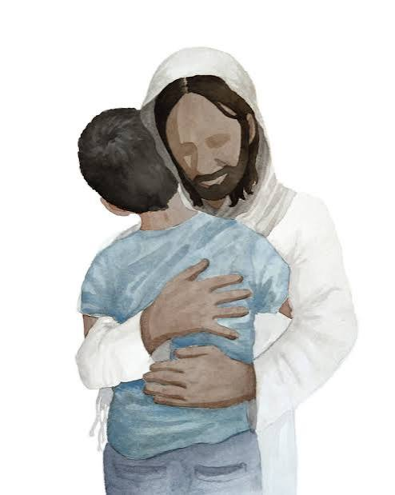
Falling Back in Love with Jesus
There was a moment for each of us when we accepted Jesus Christ as our personal Lord, Savior, and King. A moment when our walk in love with Him began. Then the years passed as the newness of our walk became more of a routine and eventually, all too often, we somehow lost our sense of love for Jesus.
This can happen to churches as well as individuals. In Revelation 2:4–7, Jesus addresses a church that had “left its first love,” its pure, burning affection for Him. The warning is clear: a cold, lukewarm love for Christ will lead to spiritual decline, but repentance and restoration are possible. This is not about religious duty; it’s about rekindling the heart’s longing for the Lover of our souls.
If you find yourself there today, do not despair for all is not lost. We can fall back in love with Jesus again by:
-Remembering His Love for you and your loss of love for Him. The depth of Christ’s love for you is that He died for you and His compassion is vast. Acknowledge where your love for Him has grown faint and ask God to renew it.
· Repenting and turning back to the way you once loved Him — with joy, devotion, and obedience. This means choosing to prioritize Him in your daily life, not just in church or Bible study.
· Doing the works you did at first such as acts of love, worship, and service that once flowed from your heart.
· Engaging in God’s presence. As Ben Cerullo notes, intimacy with Jesus comes from regularly entering His presence through daily prayer, worship, and gratitude.
· Surrounding yourself with believers who are passionate for Jesus as they bring you fellowship and encouragement. Always remember, Jesus promises to be present where two or three are gathered in His name (Matthew 18:20).
Falling back in love with Jesus is a deliberate, heartfelt choice as we remember His love, repent of our coldness, and recommit to the works and worship that once burned in our hearts. It’s a journey of returning to the very source of our joy and identity in Christ.
Prayer: “Lord, I confess that my love for You has grown cold. Help me to remember the first love I had for You. Repent me of my lukewarm heart and restore my devotion. Let me do the works I did at first, and let my life declare, ‘You are worthy, O Lord, to receive glory and honor and power.’”
“Remember therefore from where you have fallen; repent and do the works you did at first.” Revelation 2:5
(Primary sources devotionsonline.com and Inspiration Ministries)
God Bless … Pastor Dean
**********************************************************************************

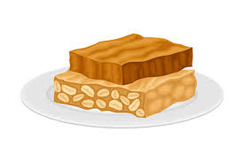

Brown Butter Apple Blondies (yields 15-18 servings)

Ingredients
- 1 cup plus 4 Tbsp. (2 1/2 sticks) unsalted butter, divided
- 12 oz. chopped apples (about 3 c.; from about 1 1/2 apples)
- Cooking spray
- 1 3/4 cups (350 g.) packed light brown sugar
- 2 1/4 tsp. pure vanilla extract, divided
- Kosher salt
- 2 large eggs, room temperature
- 1/2 tsp. baking soda
- 2 cups (240 g.) all-purpose flour
- 3/4 cup (90 g.) confectioners' sugar
- 2 Tbsp. whole milk

Directions
  - Step 1In a small pot over medium heat, melt 1 cup plus 2 tablespoons butter. Continue to cook, stirring or swirling constantly, until milk solids in bottom of pot are deeply golden brown, 4 to 6 minutes. (Butter will foam, so if needed, lift solids with a spoon from bottom of pot and check.)
  - Step 2Pour browned butter into a large heatproof bowl, making sure to scrape browned solids from bottom and sides of pot. Let cool to room temperature, about 10 minutes.
  - Step 3Meanwhile, in a large skillet over medium heat, melt remaining 2 tablespoons butter. Add apples and cook, stirring frequently, until fork-tender, 4 to 5 minutes. Let cool.
  - Step 4Preheat oven to 350°. Spray a 13" x 9" metal baking pan with cooking spray and line with parchment, leaving an overhang on 2 long opposite sides.
  - Step 5Transfer 2 tablespoons brown butter to a small bowl; set aside. To remaining brown butter, add brown sugar, 2 teaspoons vanilla, and 1 teaspoon salt and whisk until smooth. Whisk in eggs, then add baking soda and whisk just until distributed. Using a rubber spatula, fold in flour just until combined. Fold in apples. Dollop dough into prepared pan; smooth in an even layer (it will be stiff).
  - Step 6Bake blondies until just brown around the edges and deep golden on top, 20 to 25 minutes. Let cool in pan 10 minutes. Using parchment overhang, lift blondies out of pan to a wire rack and let cool completely.
  - Step 7To bowl with reserved brown butter, add confectioners’ sugar, milk, a pinch of salt, and remaining 1/4 teaspoon vanilla. Whisk until glaze is a thick, pourable consistency.
  - Step 8Drizzle glaze over cooled blondies. Let set to let glaze harden, about 5 minutes, then cut into bars.
***************************************************

We will once again be asking for donations of Halloween candy for our Trunk or Treat during Bascom Trick or Treat. We are unsure at this time of the exact date and time of the event, but if you can help out, just bring any candy you wish to donate to the church office. We would also like to have individuals come out, open your trunk and give out candy too. When we get more information, we will post it in the weekly bulletin. Thank you!
***************************************************

Below are the Daily Scriptures that go along with the pastor’s weekly messages.
Thursday  1 Oct 2026  ORDINARY  Psalm 80  Exodus 26 & 27 | Friday  2 Oct 2026  ORDINARY  Philippians 3  Exodus 28 & 29 | Saturday  3 Oct 2026  ORDINARY  Matthew 21:33-46  Exodus 30 & 31 | Sunday  4 Oct 2026  A PROPER 22(27)  { Exodus 20:1-4,7-9,12-20  Psalm 19  or  Isaiah 5:1-7  Psalm 80:7-15 }  Philippians 3:4b-14  Matthew 21:33-46  (PM, see next Sunday)
Monday  5 Oct 2026  ORDINARY  Exodus 32 & 33  (3 John) | Tuesday  6 Oct 2026  ORDINARY  Psalm 106  Exodus 34 & 35 | Wednesday  7 Oct 2026  ORDINARY  Isaiah 25  Exodus 36 & 37 | Thursday  8 Oct 2026  ORDINARY  Psalm 23  Exodus 38 & 39 | Friday  9 Oct 2026  ORDINARY  Philippians 4  Exodus 40 | Saturday  10 Oct 2026  ORDINARY  Matthew 22:1-14  Leviticus 1 & 2 | Sunday  11 Oct 2026  A PROPER 23(28)  { Exodus 32:1-14  Psalm 106:1-6,19-23  or  Isaiah 25:1-9  Psalm 23 }  Philippians 4:1-9  Matthew 22:1-14  (PM, see next Sunday)
Monday  12 Oct 2026  ORDINARY  Exodus 33:12-23  Leviticus 3 & 4 | Tuesday  13 Oct 2026  ORDINARY  Psalm 99  Leviticus 5 & 6 | Wednesday  14 Oct 2026  ORDINARY  Isaiah 44:24-45:25  Leviticus 7 & 8 | Thursday  15 Oct 2026  ORDINARY  Psalm 96  Leviticus 9 & 10 | Friday  16 Oct 2026  ORDINARY  1 Thessalonians 1  Leviticus 11 & 12 | Saturday  17 Oct 2026  ORDINARY  Matthew 22:15-22  Leviticus 13 & 14 | Sunday  18 Oct 2026  A PROPER 24(29)  { Exodus 33:12-23  Psalm 99  or  Isaiah 45:1-7  Psalm 96:1-9,(10-13) }  1 Thessalonians 1:1-10  Matthew 22:15-22  (PM, see next Sunday)
Monday  19 Oct 2026  ORDINARY  Deuteronomy 34  Leviticus 15 & 16 | Tuesday  20 Oct 2026  ORDINARY  Psalm 90  Leviticus 17 & 18 | Wednesday  21 Oct 2026  ORDINARY  Leviticus 19 & 20 & 21 | Thursday  22 Oct 2026  ORDINARY  Psalm 1  Leviticus 22 & 23 | Friday  23 Oct 2026  ORDINARY  1 Thessalonians 2:1-8  Leviticus 24 & 25 | Saturday  24 Oct 2026  ORDINARY  Matthew 22:23-46  Leviticus 26 & 27 | Sunday  25 Oct 2026  A PROPER 25(30)  { Deuteronomy 34:1-12  Psalm 90:1-6,13-17  or  Leviticus 19:1-2,15-18  Psalm 1 }  1 Thessalonians 2:1-8  Matthew 22:34-46  (PM, see next Sunday)
Monday  26 Oct 2026  ORDINARY  Joshua 1 & 2 & 3  Psalm 107 | Tuesday  27 Oct 2026  ORDINARY  Psalm 107  Joshua 4 & 5 | Wednesday  28 Oct 2026  ORDINARY  Micah 3  Psalm 43  Joshua 6 & 7 | Thursday  29 Oct 2026  ORDINARY  1 Thessalonians 2:9-3:13  Joshua 8 & 9 | Friday  30 Oct 2026  ORDINARY  Matthew 23  Joshua 10 & 11 | Saturday  31 Oct 2026  ORDINARY  Revelation 7:9-17  Psalm 34:1-10,22  1 John 3:1-3  Matthew 5:1-12 | Sunday  1 Nov 2026  A ALL SAINTS  Revelation 7:9-17  Psalm 34:1-10,22  1 John 3:1-3  Matthew 5:1-12  A PROPER 26(31)  { Joshua 3:7-17  Psalm 107:1-7,33-37  or  Micah 3:5-12  Psalm 43 }  1 Thessalonians 2:9-13  Matthew 23:1-12  (PM, see next Sunday)
Monday  2 Nov 2026  ORDINARY  Joshua 12 & 13 & 14 | Tuesday  3 Nov 2026  ORDINARY  Psalm 78  Joshua 15 & 16 | Wednesday  4 Nov 2026  ORDINARY  Amos 5:18-27  Joshua 17 & 18 | Thursday  5 Nov 2026  ORDINARY  Psalm 70  Joshua 19 & 20 | Friday  6 Nov 2026  ORDINARY  1 Thessalonians 4  Joshua 21 & 22 | Saturday  7 Nov 2026  ORDINARY  Matthew 24:1-25:13  Joshua 23 & 24 | Sunday  8 Nov 2026  A PROPER 27(32)  { Joshua 24:1-3a,14-25  Psalm 78:1-7  or  Amos 5:18-24  Psalm 70 }  1 Thessalonians 4:13-18  Matthew 25:1-13  (PM, see next Sunday)
Monday  9 Nov 2026  ORDINARY  Judges 1 & 2 & 3 & 4 | Tuesday  10 Nov 2026  ORDINARY  Psalm 123  Judges 5 & 6 | Wednesday  11 Nov 2026  ORDINARY  Zephaniah 1:4-2:3  Judges 7 & 8 | Thursday  12 Nov 2026  ORDINARY  Psalm 90  Judges 9 & 10 | Friday  13 Nov 2026  ORDINARY  1 Thessalonians 5  Judges 11 & 12 | Saturday  14 Nov 2026  ORDINARY  Matthew 25:14-30  Judges 13 & 14 | Sunday  15 Nov 2026  A PROPER 28(33)  { Judges 4:1-7  Psalm 123  or  Zephaniah 1:7,12-18  Psalm 90:1-8,(9-11),12 }  1 Thessalonians 5:1-11  Matthew 25:14-30
Monday  16 Nov 2026  ORDINARY  Psalm 95:1-7Ezekiel 34:11-16,20-24  Psalm 100  Ephesians 1:15-23  Matthew 25:31-46 | Tuesday  17 Nov 2026  ORDINARY  Ezekiel 34  Judges 15 & 16 | Wednesday  18 Nov 2026  ORDINARY  Psalm 100  Judges 17 & 18 | Thursday  19 Nov 2026  ORDINARY  Psalm 95  Judges 19 & 20 | Friday  20 Nov 2026  ORDINARY  Ephesians 1:15-23  Judges 21 | Saturday  21 Nov 2026  ORDINARY  Matthew 25:31-26:75  (Jude) | Sunday  22 Nov 2026  A CHRIST THE KING  PROPER 29(34)  Ezekiel 34:11-16,20-24  Either Psalm 100  or Psalm 95:1-7a  Ephesians 1:15-23  Matthew 25:31-46
Monday  23 Nov 2026  ORDINARY  Deuteronomy 8:7-18  Psalm 65  2 Corinthians 9:6-15  Luke 17:11-19 | Tuesday  24 Nov 2026  ORDINARY  Deuteronomy 8  Psalm 65  Matthew 27 | Wednesday  25 Nov 2026  ORDINARY  2 Corinthians 9:6-15  Luke 17:11-19  Matthew 28 | Thursday  26 Nov 2026  A THANKSGIVING  Deuteronomy 8:7-18  Psalm 65  2 Corinthians 9:6-15  Luke 17:11-19 | Friday  27 Nov 2026  ADVENT  Isaiah 64:1-9  Psalm 80:1-7,17-19  1 Corinthians 1:3-9  Mark 13:24-37 | Saturday  28 Nov 2026  ADVENT  1 Corinthians 1  (Psalm 1) | Sunday  29 Nov 2026  B 1 ADVENT  Isaiah 64:1-9  Psalm 80:1-7,17-19  1 Corinthians 1:3-9  Mark 13:24-37
Monday
30 Nov 2026
ADVENT
Isaiah 40:1-11
Psalm 85:1-2,8-13
2 Peter 3:8-15
Mark 1:1-8
***********************************************************************************

Bascom Community Calendar
The Bascom Community Calendar Project has been completed for the 65th year. Thanks again for all who assisted with this project. Calendars have been ordered and will be delivered to each of you sometime in October.
Some extra calendars will be available. Please contact Ron Lutz if you are interested – 419-448-8675.
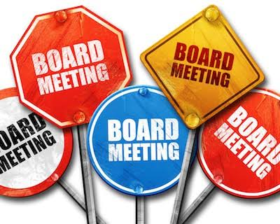
Bascom Community Church Admin. Board Meeting
August 11, 2026
Present: Marcia Abbott, Pastor Dean, Bob Manz, Lori Clay, Carol Reisner, Helen Emerine Not Present: Shelby Lopez, Morgan Johnson
Pastor Dean opened with prayer.
Regarding the church building, a pump failed on the south boiler. It was shut down until repaired by Craig Illich with Aichholz-Illig. Cost was $786.12. The state inspector was here today, and the boiler passed inspection.
Front & back door locks were replaced by General Locksmith and Maintenance LLC at a cost of $244.35. 15 keys have been passed out including two to the cleaning service with recipients tracked. Pastor Dean & Admin Chair has the record.
Concerns were expressed about the flooring on the first floor possibly containing asbestos (see parsonage below). A sample was taken and sent to SGLI for testing on 7/29/26. The results were received on 8/5/2026. “No asbestos fibers detected.” Please note that these tiles are also in three rooms in the basement but not on the main floor.
It was confirmed today that the parking lot is still scheduled for sealing on next Tuesday (August 18) barring any extreme weather caused delay.
H&E Janitorial replaced A Mint Clean as cleaning service provider effective July 1, 2026. They charged an initial fee of $250.00 for a deep clean (over 6 hours on a Saturday morning) to clean targeted areas that had not been addressed for a period. Josh Kinney (owner) also suggested that we have the exterior windows professionally cleaned at an approximate cost of $600.00 (note: he will outsource the cleaning to All Ohio Soft Wash [567-230-1852]). The board decided to do some checking around first. Pastor Dean will ask if the price includes caulking. Bob Manz suggested the same company do the caulking and cleaning. He also recommends that we have them cleaned annually, preferably a couple of weeks before VBS. Note: his children attend our Ecumenical VBS as he is Pastor Amy of St. John’s UCC son. Bugs were noticed in curtains etc. Marcia will clean drapes and recommends for us to spray for insects (bug remediation) or have a professional do so (recommendation: Robbin’s Pest Control out of Fostoria [419-619-0686] at an estimated cost of $140.00). We have had him do this before. Helen Emerine will schedule a walk-through estimate and will also ask about windows. Recommended that we verify all windows are closing properly & perform any necessary corrections to minimize insect overabundance.
There is a need for us to go through the toys downstairs and sort through and clean the toys that we keep. This is a winter project. We have too many toys. There are traces of insects in some of the plastic toy boxes. In the meantime, Dean will work on sorting through the toys that are currently in the nursery.
Regarding the parsonage, the carpet installer refused to install bedroom carpet on 7/20/26 due to concerns that flooring had asbestos in it & attaching tack strip would expose the team to asbestos fibers. Marcia Abbott (Admin Chair) was notified of situation, and a sample was sent to Grey Scope Labs for testing. The results received on 7/31/26 were no asbestos detected in the samples. Admin Chair was provided a hard copy of results for documentation. Carpet was installed on August 11th. Pastor Dean & Danene are funding the carpet.
The water heater failed on July 31st. Pastor Dean was unable to determine the cause. Tiffin Deluxe was contacted & determined that it was a non-circuit breaker issue. It was resolved at a cost of $164.50.
Chuck & Dean have not scheduled a time to reseal the roof over the office and kitchen (north side of parsonage).
There is no quote yet for trimming parsonage tree from Hawk Tree Service.
Living Water Fund: RTR balance as of 6/30/2026 is $495.49. We have received $1,505.00 so far, which has been given to Betty for deposit (Jeanne VanBuskirk is the other account signee). A work day will be scheduled to confirm letters and mailing addresses with Morgan, Helen, and Pastor Dean.
In new business, we will be needing two new council representatives as Bob Manz & Marcia Abbott will be leaving the board. Has anyone expressed an interest? We need a new chair for 2027. We will put a request for new members in the bulletin.
American Power & Gas of Ohio is our new fixed rate electric provider at $0.0745 per kWh for 3 months. Bob Manz can provide additional information.
Regarding the 501C3, Bob Manz stated to keep accepting the Kroger rebate checks and don’t renew the corporation.
Lori Clay gave the financial report. The current checkbook balance is $12,871.05. Helen Emerine motioned to accept the report, Bob Manz seconded it. All were in favor, and the motion carried.
It was discussed that we don’t have a complete listing of birthdays and anniversaries for those that attend church and their families. We will provide index cards for the next few Sundays so that these can be collected, and an updated list can be compiled. This list will be used for Sunday’s announcements because the Bascom calendar doesn’t necessarily include everyone that attends.
Helen Emerine mentioned that it’s important to perform routine maintenance to prevent further problems.
Helen Emerine motioned to end the meeting, and Carol Reisner seconded the motion. All were in favor, and the motion carried. Next meeting will be October 13th, 2026 at 6:00 p.m.
Board Members
- Term expires 12/31/2026
  - Marcia Abbott (2026 Chairperson)
  - Bob Manz
- Term expires 12/31/2027
  - Morgan Bush-Johnson
  - Shelby Lopez
- Term expires 12/31/2028
  - Helen Emerine
  - Carol Reisner
- Non-voting members
  - Dean Durant, Pastor
  - Laura (Lori) Clay

Note: Administrative Council Chairperson votes only when a motion vote has resulted in a tie.
***********************************************************************************
Adult Sunday School
In September, the Adult Sunday School Class studied The Twelve Disciples, a Life Guide Study that included a lesson on each of the disciples of Jesus Christ. Danene and Pastor Dean will be leading our class in October and November, respectively.
Please join us!!!!
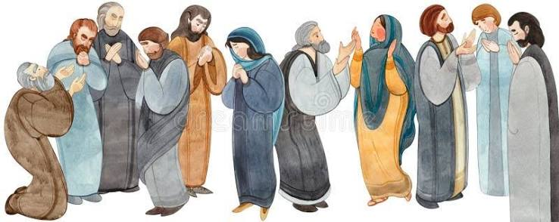
**********************************************************************************


Tomb of the Unknown Soldier
1. How many steps does the guard take during his walk across the tomb of the Unknowns and why? 21 steps: It alludes to the twenty-one gun salute which is the highest honor given any military or foreign dignitary.
2. How long does he hesitate after his about face to begin his return walk and why? 21 seconds, for the same reason as answer number 1.
3. Why are his gloves wet? His gloves are moistened to prevent his losing his grip on the rifle.
4. Does he carry his rifle on the same shoulder all the time and, if not, why not? He carries the rifle on the shoulder away from the tomb. After his march across the path, he executes an about face and moves the rifle to the outside shoulder.
5. How often are the guards changed? Guards are changed every thirty minutes, twenty-four hours a day, 365 days a year.
6. What are the physical traits of the guard limited to? For a person to apply for guard duty at the tomb, he must be between 5′ 10′ and 6′ 2′ tall and his waist size cannot exceed 30.
They must commit 2 years of life to guard the tomb, live in a barracks under the tomb, and cannot drink any alcohol on or off duty for the rest of their lives. They cannot swear in public for the rest of their lives and cannot disgrace the uniform or the tomb in any way.
After two years, the guard is given a wreath pin that is worn on their lapel signifying they served as guard of the tomb. There are only 400 presently worn. The guard must obey these rules for the rest of their lives or give up the wreath pin.
The shoes are specially made with very thick soles to keep the heat and cold from their feet. There are metal heel plates that extend to the top of the shoe in order to make the loud click as they come to a halt.
There are no wrinkles, folds or lint on the uniform. Guards dress for duty in front of a full-length mirror.
The first six months of duty a guard cannot talk to anyone nor watch TV.
All off duty time is spent studying the 175 notable people laid to rest in Arlington National Cemetery.
A guard must memorize who they are and where they are interred. Among the notables are:
President Taft,
Joe Lewis {the boxer}
Medal of Honor winner Audie L. Murphy, the most decorated soldier of WWII and of Hollywood fame.
Every guard spends five hours a day getting his uniforms ready for guard duty.
In 2003 as Hurricane Isabelle was approaching Washington, DC, our US Senate/House took 2 days off with anticipation of the storm. On the ABC evening news, it was reported that because of the dangers from the hurricane, the military members assigned the duty of guarding the Tomb of the Unknown Soldier were given permission to suspend the assignment. They respectfully declined the offer, “No way, Sir!” Soaked to the skin, marching in the pelting rain of a tropical storm, they said that guarding the Tomb was not just an assignment, it was the highest honor that can be afforded to a service person. The tomb has been patrolled continuously, 24/7, since 1930.


OCTOBER-NOVEMBER, 2026 EVENTS
October 3 Men’s breakfast at GW’S Fine Foods 9:00 a.m.
October 4 Communion Sunday 10:30 a.m.
October 12 Columbus Day
October 13 Admin. Board Meeting 6:00 p.m.
October 31 Halloween
November 1 Don’t forget to FALL BACK….Daylight Savings Time Ends
November 7 Men’s Breakfast at American Table in Fostoria 9:00 a.m.
November 8 Communion Sunday 10:30 a.m.
November 11 Veteran’s Day
November 15 Last day to return Operation Christmas Child shoeboxes
November 22 Hanging of the Greens after worship service
November 22 Ecumenical Thanksgiving Service at Hopewell Church of God with Pastor Dean giving the message
November 26 Thanksgiving Day
***********************************************************************************
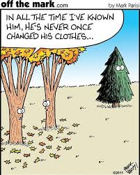

5660 W. Tiffin St.
Bascom, Ohio 44809
419-937-2578
www.bascomchurch.com

